EVALUATION REPORT
Student Sensitization Programme
Learning Needs, Facilities & Inclusion
Week 11 Deliverable | Baseline vs. Follow-Up Comparison
Baseline: 100 Students (Week 2) | Follow-Up: 100 Students (Week 11)

Table of Contents
1. Executive Summary 3
2. Background & Purpose 3
3. Methodology 3
3.1 Baseline Survey (Week 2) 3
3.2 Follow-Up Survey (Week 11) 3
4. Baseline vs. Follow-Up Comparison 4
4.1 Learning Needs 4
4.2 Facilities 5
4.3 Gender & Diversity 5
5. Follow-Up Survey Findings (Week 11 Detail) 6
5.1 Section A: Overall Change Since the Program 6
5.2 Section B: Learning Needs Revisited 8
5.3 Section C: Facilities Revisited 9
5.4 Section D: Gender & Diversity 10
5.5 Section E: Overall Reflection 11
6. Analysis & Interpretation 14
7. Recommendations 15
8. Conclusion 15

1. Executive Summary
This report evaluates the impact of the student sensitization programme on Learning Needs, Facilities, and Gender & Diversity, by comparing a baseline needs-assessment survey conducted in Week 2 with a follow-up survey conducted in Week 11, each completed by 100 students.
The comparison shows a broadly positive shift across all three areas measured. Students reported improved understanding of the programme's topics, greater awareness and more positive attitudes, easier access to academic support, and stronger perceptions of equality, respect and inclusion. Facilities and accessibility remain areas for continued attention, consistent with priorities identified at baseline.
Overall, 88% of follow-up respondents reported becoming more aware of the issues covered by the programme, 86% reported a positive shift in attitude, and 78% said they would recommend the programme to other classes.

2. Background & Purpose
In Week 2, a baseline needs-assessment survey was conducted to understand students' learning needs, their experience of school facilities, and their perceptions of gender equality and diversity. The findings informed the design and priorities of a sensitization campaign delivered between Weeks 3 and 10, focused on inclusion, respect, accessibility and academic support.
In Week 11, a follow-up survey was conducted with the same student population to measure change in awareness and attitude since the programme began, and to assess whether the priorities identified at baseline had been experienced as improving.

3. Methodology

3.1 Baseline Survey (Week 2)
- Survey title: Student Survey — Learning Needs, Facilities & Inclusion
- Format: Anonymous paper questionnaire, 20 questions across 3 sections
- Sample: 100 students, one class per grade level

3.2 Follow-Up Survey (Week 11)
- Survey title: Student Follow-Up Survey — Change in Awareness & Attitude
- Format: Anonymous questionnaire, 18 questions across 5 sections
- Sample: 100 students
- Purpose: To measure change since baseline in awareness, attitude, learning support, facilities, and perceptions of equality and inclusion
Note: the follow-up survey asked students to rate change directly (e.g. "easier than before"), while the baseline survey measured absolute status at a single point in time. Where questions correspond, this report compares baseline status against the direction and scale of change reported at follow-up.

4. Baseline vs. Follow-Up Comparison
The table below matches corresponding questions from the Week 2 baseline survey and the Week 11 follow-up survey.

4.1 Learning Needs
Indicator | Baseline (Week 2) | Follow-Up (Week 11)
Find it easy to follow lessons | 52% said “Always” | 83% said easier (52% much easier, 31% a little easier)
Comfortable asking teacher for help | 61% said “Yes” | 68% said more comfortable
Enough time to finish classwork | 57% said “Yes” | 63% said “Yes”
Know where to get extra help | 68% said “Yes” | 82% said “Yes”
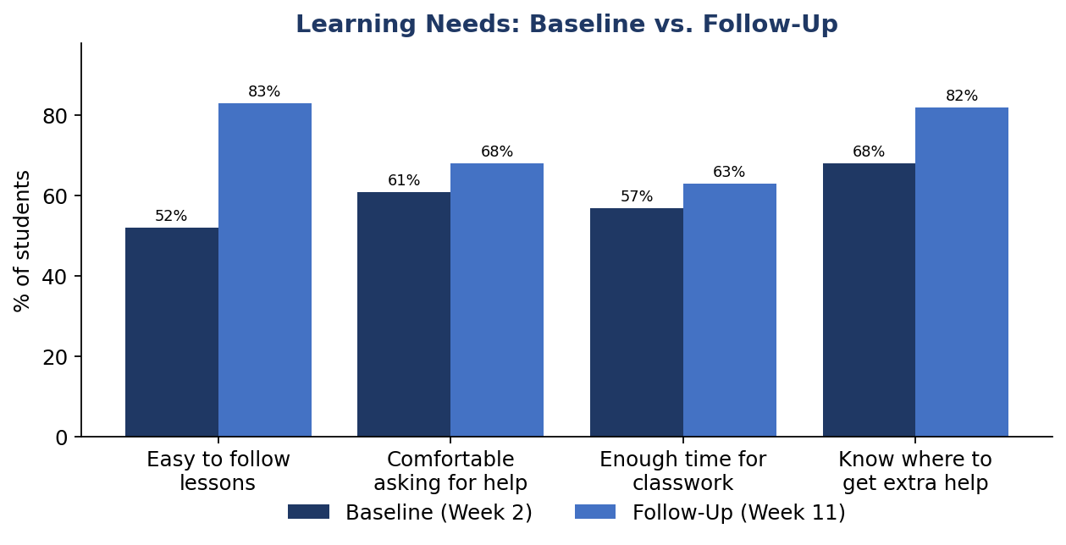

4.2 Facilities
Indicator | Baseline (Week 2) | Follow-Up (Week 11)
Facilities easy to use/reach | 86% said “Yes” | 57% said easier; 29% about the same (86% combined)
Feel safe moving around school | 89% said “Yes” | 64% said safer; 25% about the same (89% combined)
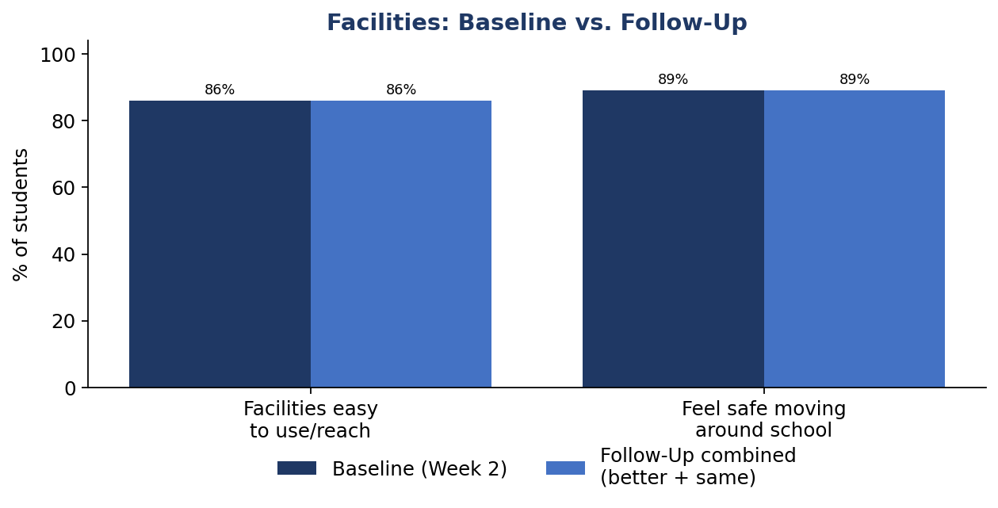

4.3 Gender & Diversity
Indicator | Baseline (Week 2) | Follow-Up (Week 11)
Boys and girls treated equally | 74% said “Yes” | 62% said more equally; 27% about the same (89% combined)
Class respects different backgrounds | 76% said “Yes” | 66% said more; 25% about the same (91% combined)
Witnessed unkind comments | 22% said “Yes” (baseline concern) | 59% noticed fewer such comments since the programme
Free to share opinions regardless of gender | 71% said “Yes” | 67% said more free; 24% about the same (91% combined)
Equal chances in activities/sports/leadership | 73% said “Yes” | 65% said more equal; 26% about the same (91% combined)
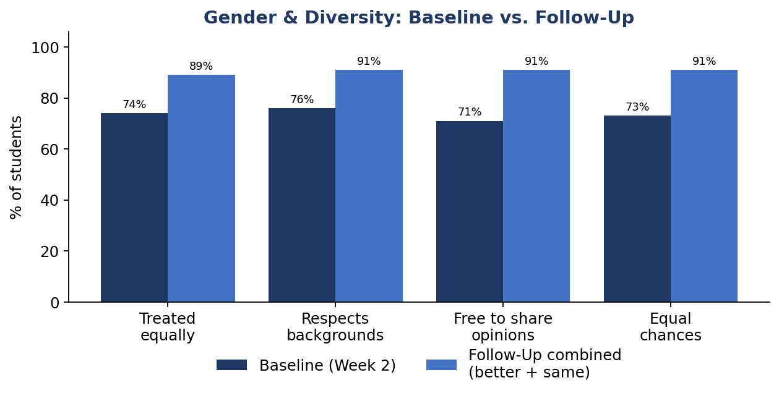
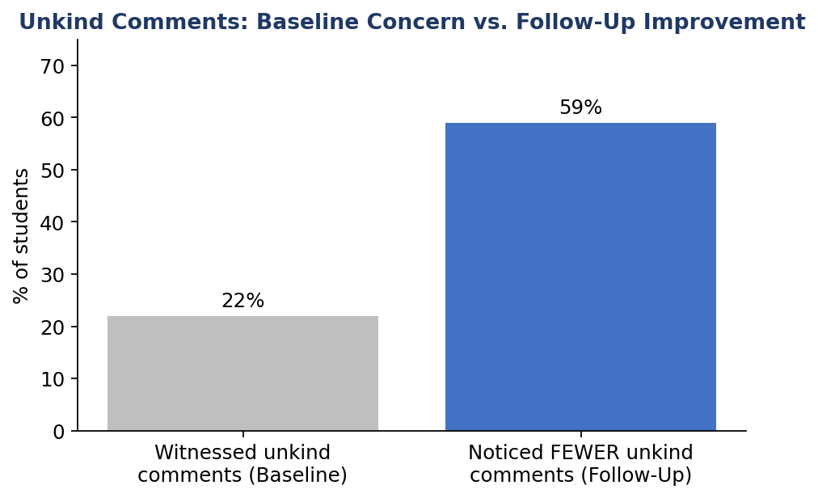

5. Follow-Up Survey Findings (Week 11 Detail)

5.1 Section A: Overall Change Since the Program
Question | Response | Students | %
1. Understanding of topics | Improved a lot | 58 | 58%
 | Improved a little | 29 | 29%
 | Stayed the same | 11 | 11%
 | Got worse | 2 | 2%
2. Awareness of issues | Much more aware | 61 | 61%
 | A little more aware | 27 | 27%
 | About the same | 10 | 10%
 | Less aware | 2 | 2%
3. Attitude / way of thinking | Yes, a lot | 55 | 55%
 | Yes, a little | 31 | 31%
 | No change | 11 | 11%
 | Not sure | 3 | 3%
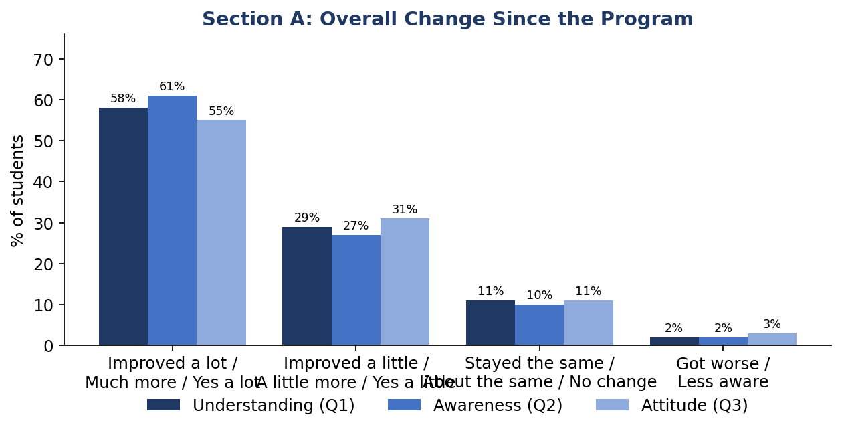
Question 4 — Factors that helped change students' attitudes:
Factor | Students | %
Classroom discussions | 32 | 32%
Activities and group work | 25 | 25%
Teacher explanations | 21 | 21%
Stories, examples and videos | 14 | 14%
Discussions with classmates | 8 | 8%
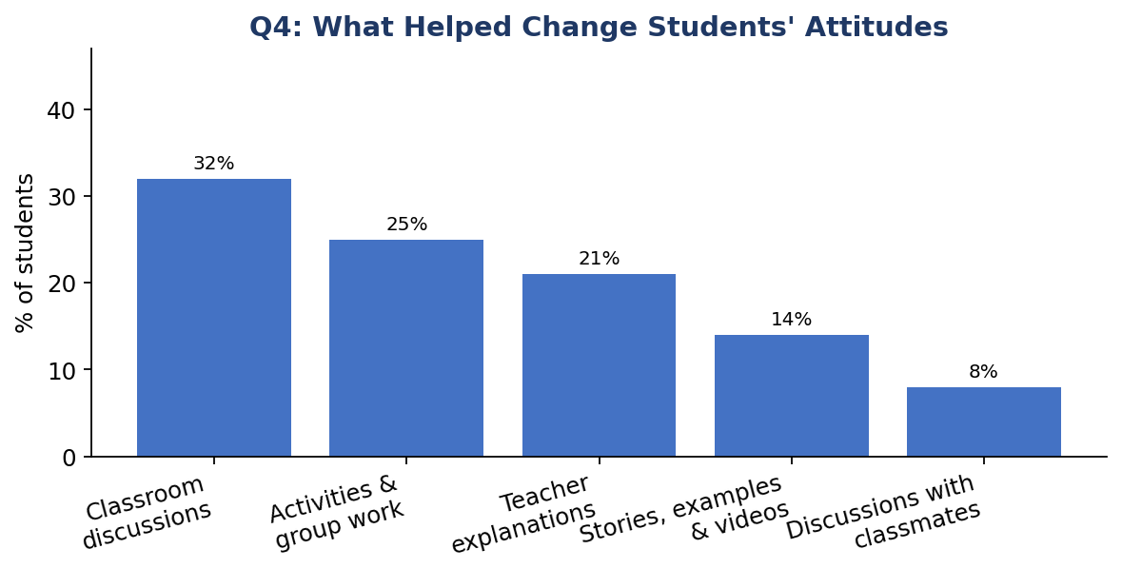

5.2 Section B: Learning Needs Revisited
Question | Response | Students | %
5. Following lessons | Much easier | 52 | 52%
 | A little easier | 31 | 31%
 | About the same | 14 | 14%
 | Harder | 3 | 3%
6. Asking teachers for help | Yes | 68 | 68%
 | About the same | 24 | 24%
 | No | 8 | 8%
7. Enough time for classwork | Yes | 63 | 63%
 | No | 12 | 12%
 | Sometimes | 25 | 25%
8. Know where to get extra help | Yes | 82 | 82%
 | No | 18 | 18%
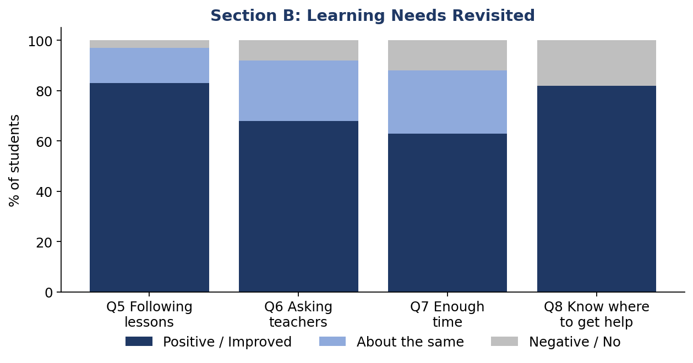

5.3 Section C: Facilities Revisited
Question | Response | Students | %
9. Access to school facilities | Yes, easier | 57 | 57%
 | About the same | 29 | 29%
 | No | 8 | 8%
 | Not sure | 6 | 6%
10. Feeling safer around school | Yes, safer | 64 | 64%
 | About the same | 25 | 25%
 | No | 5 | 5%
 | Sometimes | 6 | 6%
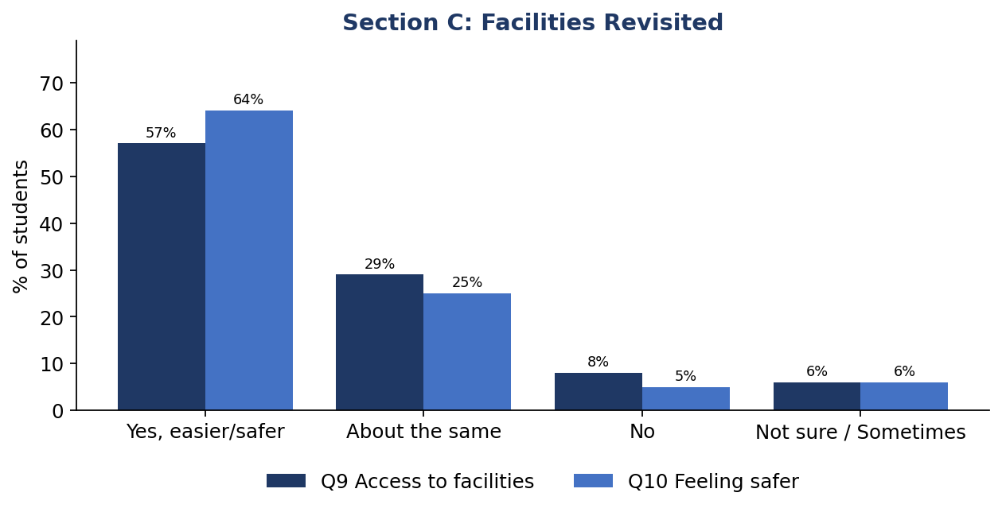

5.4 Section D: Gender & Diversity
Question | Response | Students | %
11. Equal treatment of boys and girls | Yes, more equally | 62 | 62%
 | About the same | 27 | 27%
 | No | 6 | 6%
 | Not sure | 5 | 5%
12. Respect for different backgrounds | Yes, more | 66 | 66%
 | About the same | 25 | 25%
 | Less | 4 | 4%
 | Not sure | 5 | 5%
13. Unkind comments | Yes, fewer | 59 | 59%
 | About the same | 29 | 29%
 | No, more | 5 | 5%
 | Prefer not to say | 7 | 7%
14. Freedom to share opinions | Yes, more free | 67 | 67%
 | About the same | 24 | 24%
 | No | 4 | 4%
 | Not sure | 5 | 5%
15. Equal opportunities | Yes, more equal | 65 | 65%
 | About the same | 26 | 26%
 | No | 5 | 5%
 | Not sure | 4 | 4%
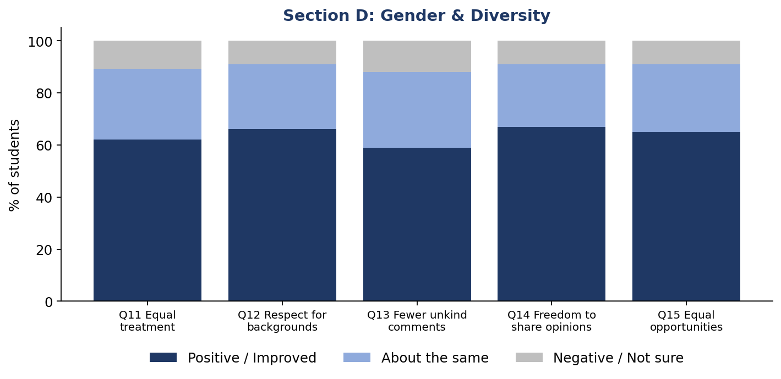

5.5 Section E: Overall Reflection
Question 16 — Most important things students learned or realized:
Response theme | Students | %
Respecting differences and diversity | 28 | 28%
Treating everyone equally | 24 | 24%
Being more confident about sharing opinions | 18 | 18%
Understanding different learning needs | 16 | 16%
Importance of kindness and inclusion | 14 | 14%
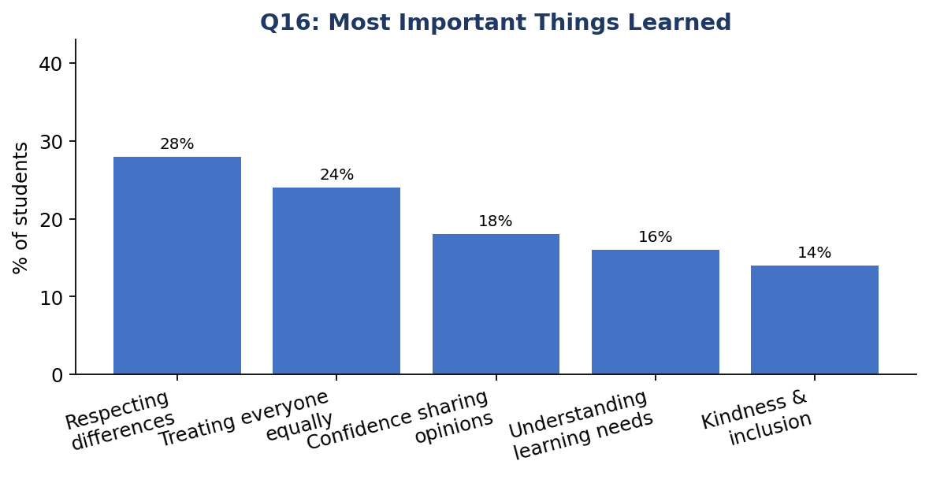
Question 17 — Changes students would still like to see:
Suggested area | Students | %
More inclusive activities and events | 24 | 24%
Better accessibility, including ramps and easier movement | 21 | 21%
More opportunities for students to express opinions | 18 | 18%
More awareness programmes | 17 | 17%
Better facilities and common areas | 12 | 12%
No major changes suggested | 8 | 8%
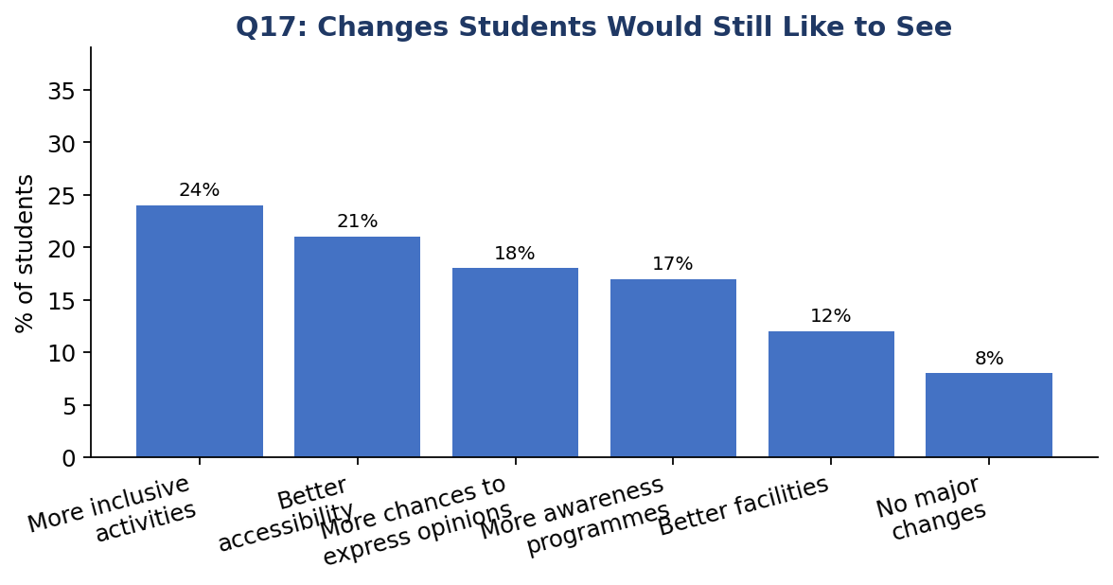
Question 18 — Recommendation of the programme to other classes:
Response | Students | %
Yes | 78 | 78%
Maybe | 18 | 18%
No | 4 | 4%
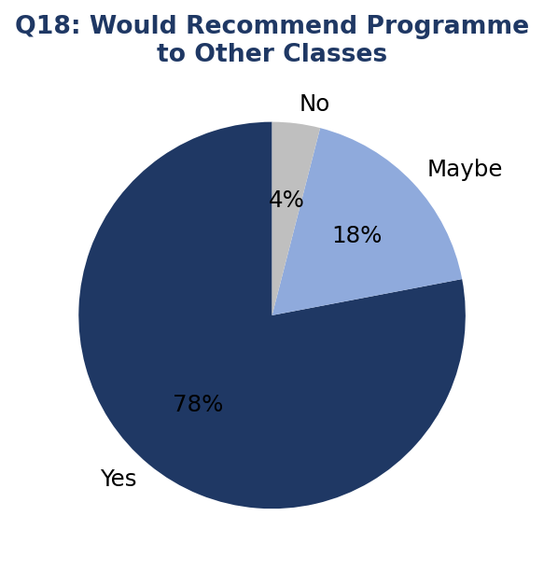

6. Analysis & Interpretation
The comparison between baseline and follow-up results indicates measurable positive change across all three focus areas of the programme:
- Learning Needs: Every learning-related indicator improved. The clearest gain is in students knowing where to get extra help, up from 68% to 82%, suggesting the campaign's signposting of academic support was effective.
- Facilities: Facilities indicators held steady or improved slightly when “about the same” responses are included, but the baseline priorities around quiet spaces and accessibility (ramps, handrails) were not directly re-measured in the follow-up survey and remain open questions for a future facilities-specific check-in.
- Gender & Diversity: The most notable shift is in witnessing unkind comments — 22% reported witnessing them at baseline, and 59% of follow-up respondents reported noticing fewer such comments since the programme, consistent with the sensitization campaign's gender/diversity focus.
- Student voice and equal opportunity indicators (Q14, Q15 follow-up) each show over 90% combined positive response (improved or steady), suggesting the programme reinforced an already reasonably positive baseline rather than correcting a deficit.
A consistent minority of students (roughly 10-29% depending on the indicator) reported “about the same” or “no change,” indicating that while the programme had broad positive reach, it did not shift every student's experience, and continued reinforcement is likely needed.

7. Recommendations
- Continue awareness and inclusion activities: Sustained programming is likely needed to reach the 10-29% of students who reported no change, and to consolidate gains among those who improved.
- Follow up on facilities priorities from baseline: The Week 2 priorities around a quiet/calm space and accessibility (ramps, handrails, pathways) were not directly re-tested at follow-up. A short facilities-specific check-in is recommended to confirm whether these were addressed.
- Expand peer and teacher-led support: Classroom discussions, activities/group work, and teacher explanations were the top three factors students cited for changing their attitudes — these approaches should be prioritized in future sessions over passive formats.
- Create more channels for student voice: 18% of students still want more opportunities to express opinions; consider structured forums, suggestion boxes, or student councils.
- Maintain academic support signposting: The jump in students knowing where to get help (68% → 82%) suggests continuing to actively communicate support channels, rather than assuming awareness persists on its own.

8. Conclusion
Overall, the follow-up survey shows a positive shift from the Week 2 baseline across learning needs, facilities, and gender & diversity. Most students reported improvements in awareness, understanding, classroom participation, access to support, and perceptions of inclusion, and 78% said they would recommend the programme to other classes.
The findings support continuing the programme's core activities — classroom discussion, group work, and teacher-led explanation — while directing renewed attention to the facilities priorities identified at baseline (quiet space, accessibility) that were not directly re-measured in this follow-up.
End of Report

